**Question 1: Do AgNPs have an effect on yellow perch N, P, C and Tag excretion?**

**Answer 1: AgNPs have no effect on N or P excretion and a minor effect on DOC excretion.**

**Question 2: How does Tag release vary with time?**

**Answer 2: Tag release increases with time from the first year of AgNPs addition to the second**

# Log10 N, P, C excretion vs. log10 mass for all years by lake

* very bad relationships, may be due to the low variance in mass among individuals (from 0.4 to 8g for the entire dataset)

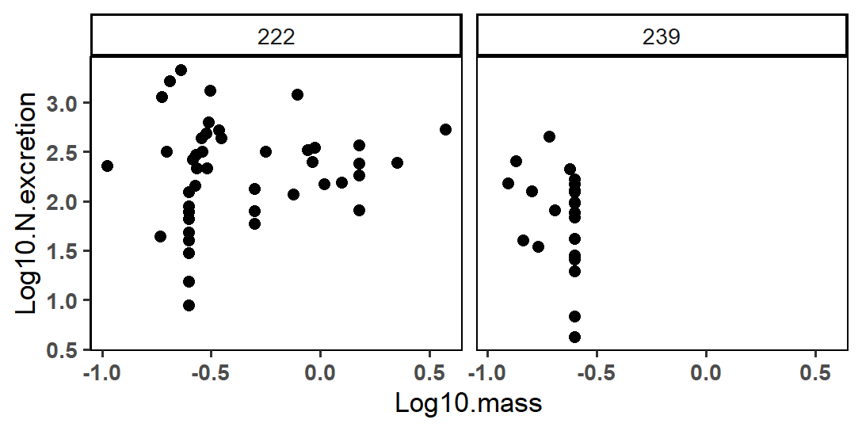

* Coeff of variation L222 = 0.17, coeff of variation L239 = -1.44

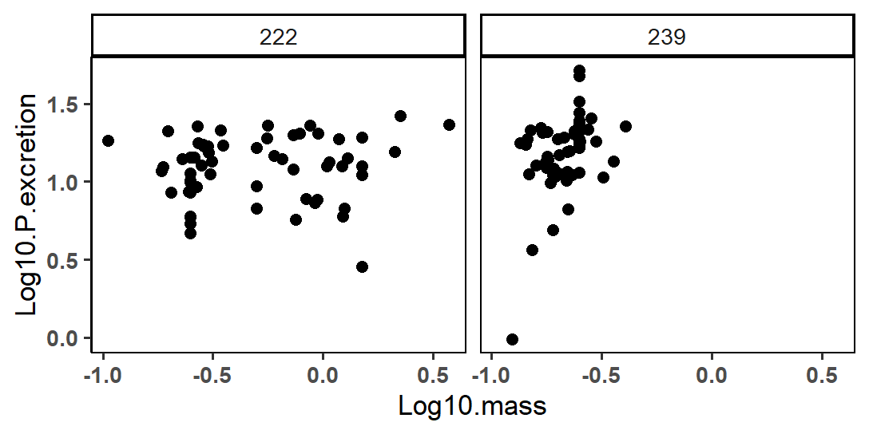

* Coeff of variation L222 = 0.05, coeff of variation L239 = 1.06

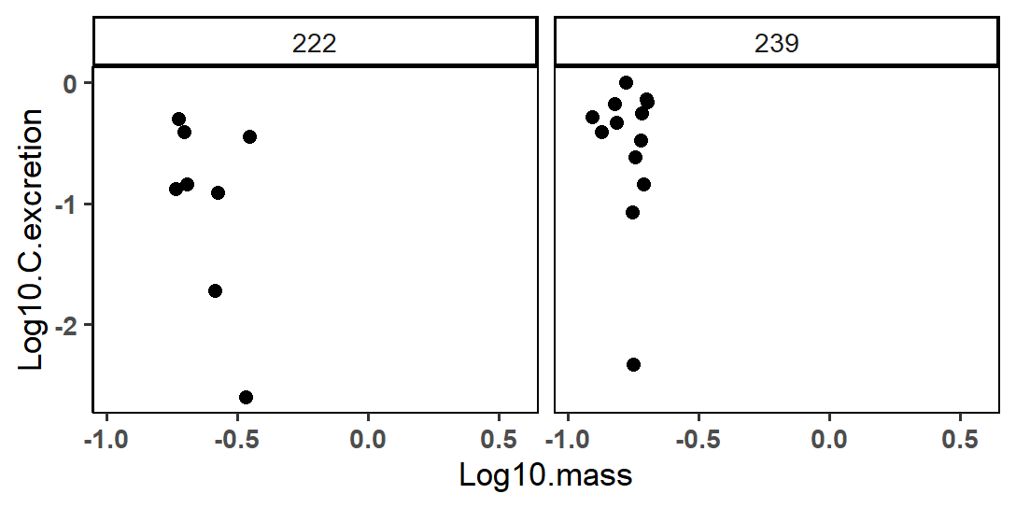

* Coeff of variation L222 = -3.54, coeff of variation L239 = -1.34

# Anova: TDN excretion in 2015 ~ Lake

* Excluding 2014 because of low sample sizes for both lakes; yet may be a difference between 2014/2015

summary(aov.Nnx)

Df Sum Sq Mean Sq F value Pr(>F)

Lake 1 10982116 10982116 2.022 0.168

Residuals 23 124933651 5431898

25 observations deleted due to missingness

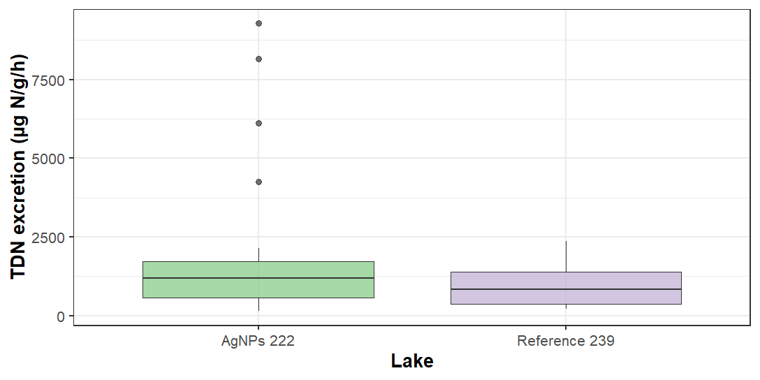

# Anova: TDN excretion in 2012, 2015 ~ Lake*Year

summary(aov.Nx)

Df Sum Sq Mean Sq F value Pr(>F)

Lake 1 7830723 7830723 3.486 0.0671 .

Year 1 45364532 45364532 20.195 3.56e-05 ***

Lake:Year 1 8066904 8066904 3.591 0.0633 .

Residuals 56 125797225 2246379

---

Signif. codes: 0 ‘***’ 0.001 ‘**’ 0.01 ‘*’ 0.05 ‘.’ 0.1 ‘ ’ 1

40 observations deleted due to missingness

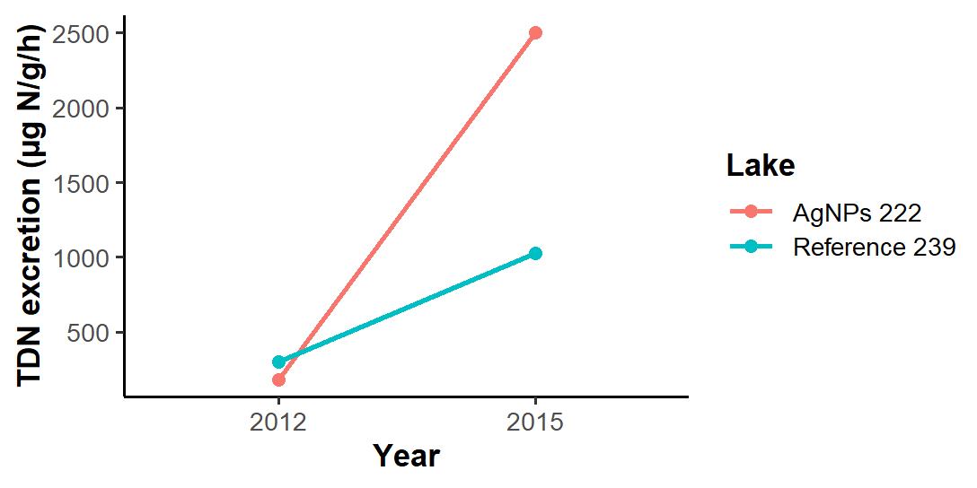

# Anova: TDP excretion in 2014, 2015 ~ Lake

> summary(aov.Pnx)

Df Sum Sq Mean Sq F value Pr(>F)

Lake 1 21327 21327 20.1 2.56e-05 ***

Residuals 76 80625 1061

---

Signif. codes: 0 ‘***’ 0.001 ‘**’ 0.01 ‘*’ 0.05 ‘.’ 0.1 ‘ ’ 1

22 observations deleted due to missingness

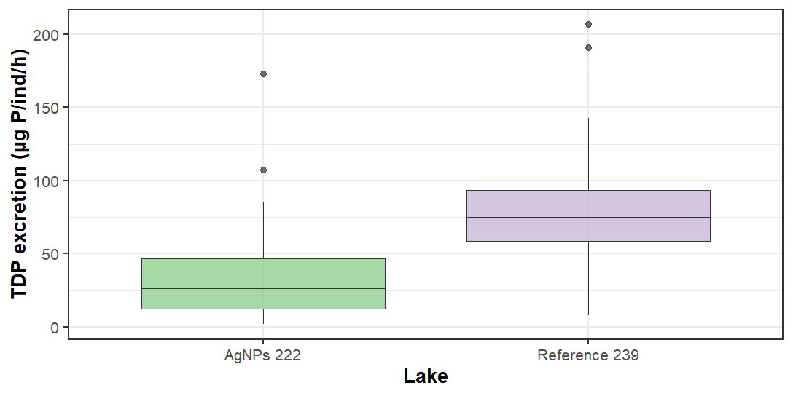

# Anova: TDP excretion in 2012, 2014, 2015 ~ Lake*Year

> summary(aov.Px)

Df Sum Sq Mean Sq F value Pr(>F)

Lake 1 63504 63504 77.875 1.79e-14 ***

Year 2 23053 11527 14.135 3.40e-06 ***

Lake:Year 2 12831 6415 7.867 0.000638 ***

Residuals 111 90517 815

---

Signif. codes: 0 ‘***’ 0.001 ‘**’ 0.01 ‘*’ 0.05 ‘.’ 0.1 ‘ ’ 1

33 observations deleted due to missingness

> summary(glm.Px)

Call:

glm(formula = massnorm.P.excr ~ Lake * Year, data = NPexcr)

Deviance Residuals:

Min 1Q Median 3Q Max

-77.645 -15.354 -5.301 9.408 111.507

Coefficients:

Estimate Std. Error t value Pr(>|t|)

(Intercept) 21.568 6.385 3.378 0.001009 **

Lake239 73.694 9.148 8.055 9.84e-13 ***

Year2014 -3.835 9.148 -0.419 0.675875

Year2015 40.949 9.030 4.535 1.47e-05 ***

Lake239:Year2014 -29.953 13.020 -2.300 0.023289 *

Lake239:Year2015 -50.760 12.855 -3.949 0.000138 ***

---

Signif. codes: 0 ‘***’ 0.001 ‘**’ 0.01 ‘*’ 0.05 ‘.’ 0.1 ‘ ’ 1

(Dispersion parameter for gaussian family taken to be 815.4644)

Null deviance: 189905 on 116 degrees of freedom

Residual deviance: 90517 on 111 degrees of freedom

(33 observations deleted due to missingness)

AIC: 1124.2

Number of Fisher Scoring iterations: 2

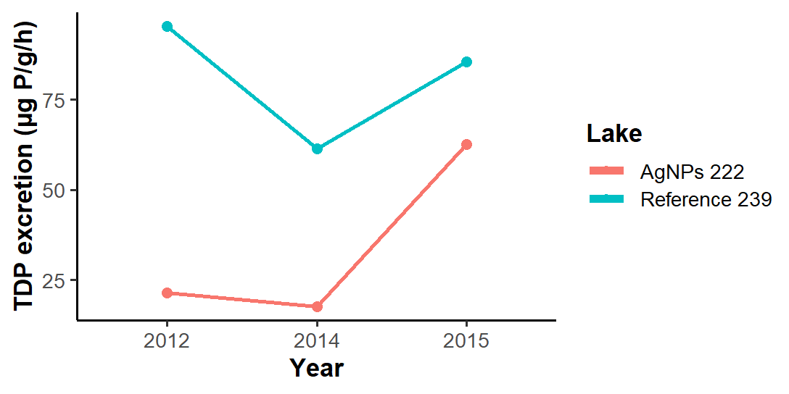

# Anova: DOC excretion in 2015 ~ Lake

summary(aov.C)

Df Sum Sq Mean Sq F value Pr(>F)

Lake 1 0.2811 0.28111 4.41 0.0493 *

Residuals 19 1.2112 0.06375

---

Signif. codes: 0 ‘***’ 0.001 ‘**’ 0.01 ‘*’ 0.05 ‘.’ 0.1 ‘ ’ 1

79 observations deleted due to missingness

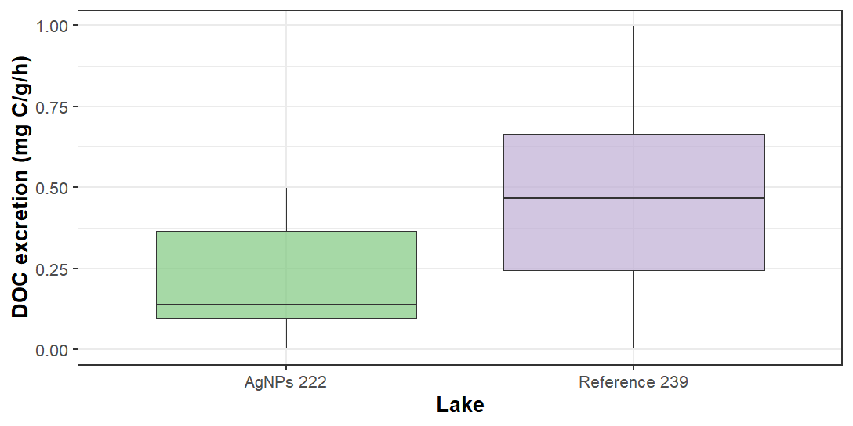

*Note: very low DOC excretion for both lakes*

# Anova: Excreted N:P in 2012, 2015~ Lake*Year

> summary(aov.NPx)

Df Sum Sq Mean Sq F value Pr(>F)

Lake 1 15953 15953 2.579 0.11389

Year 1 69299 69299 11.205 0.00146 **

Lake:Year 1 262 262 0.042 0.83770

Residuals 56 346337 6185

---

Signif. codes: 0 ‘***’ 0.001 ‘**’ 0.01 ‘*’ 0.05 ‘.’ 0.1 ‘ ’ 1

40 observations deleted due to missingness

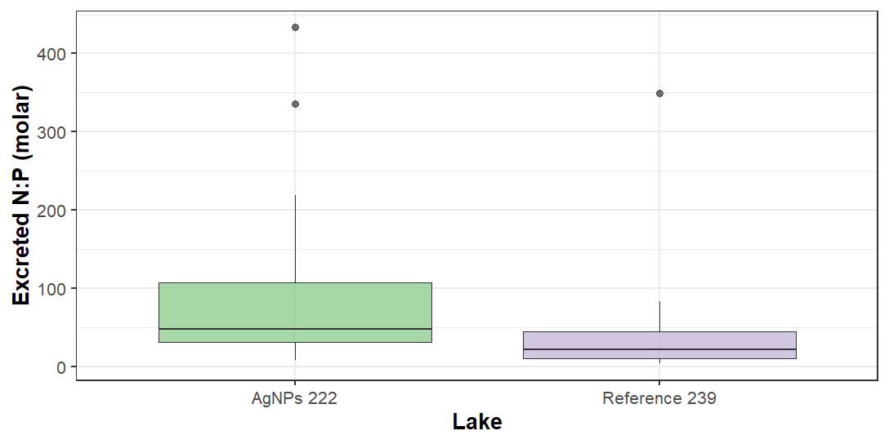

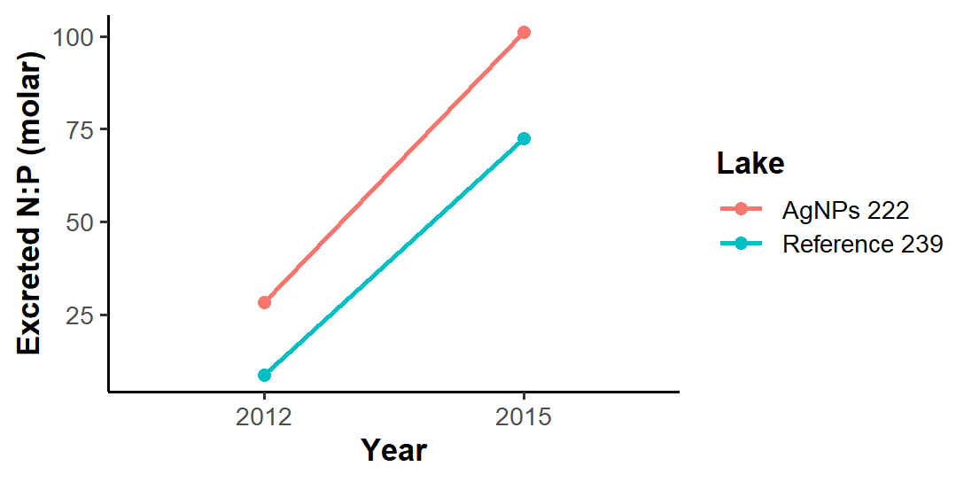

# Anova: Excreted C:N in 2015 ~ Lake

> summary(aov.CN)

Df Sum Sq Mean Sq F value Pr(>F)

Lake 1 4.554 4.554 3.152 0.11

Residuals 9 13.004 1.445

139 observations deleted due to missingness

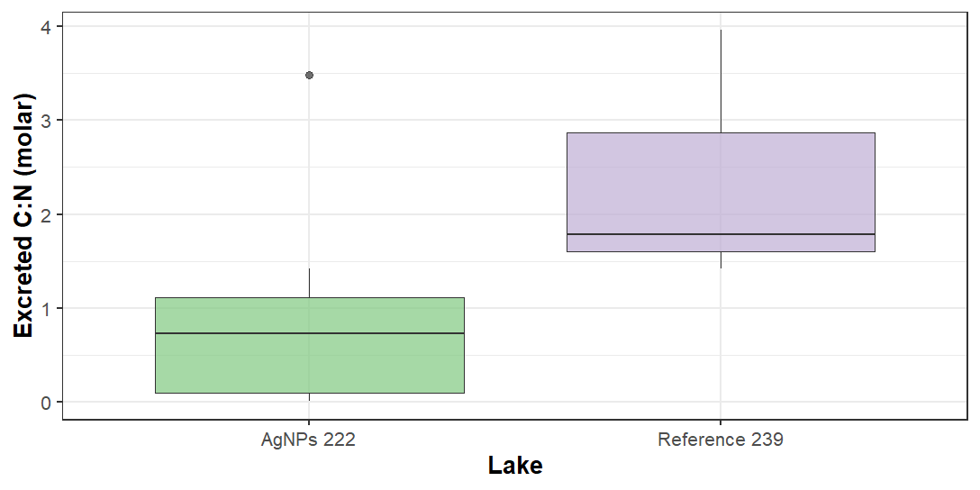

*Note: very low DOC excretion for both lakes + no time series because only have DOC data in 2015*

# Anova: Excreted C:P in 2015 ~ Lake

# ..excreted C:P (molar) in 2015 ----

> aov.CP <- aov(Excreted.CP ~ Lake,

+ data = NPexcr)

> summary(aov.CP)

Df Sum Sq Mean Sq F value Pr(>F)

Lake 1 117838 117838 1.376 0.255

Residuals 19 1627291 85647

129 observations deleted due to missingness

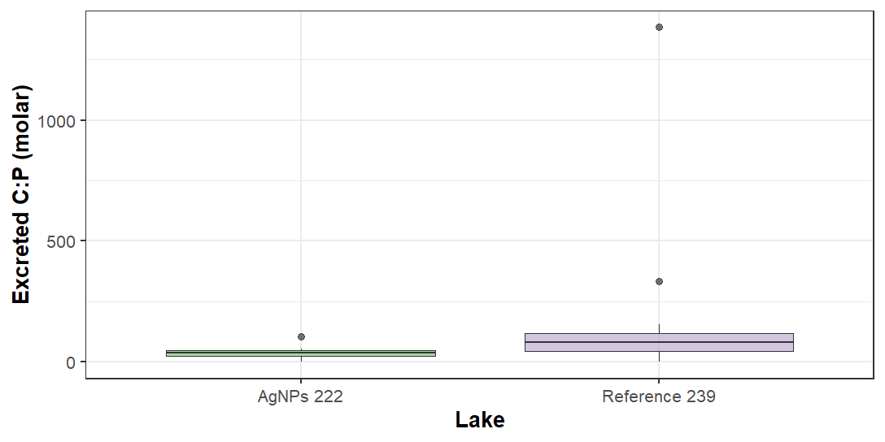

# Anova: Tag excretion ~ Year

> summary(aov.Tag)

Df Sum Sq Mean Sq F value Pr(>F)

Year 1 1655 1654.9 5.802 0.0212 *

Residuals 36 10268 285.2

---

Signif. codes: 0 ‘***’ 0.001 ‘**’ 0.01 ‘*’ 0.05 ‘.’ 0.1 ‘ ’ 1

112 observations deleted due to missingness

